**INSTRUCTIONS:**

**We are trying to understand more about how people with autism, or autistic tendencies, and people without autism search the web.**

* **For the search queries below please indicate what search terms you would use to search the web.**
* **There are no right or wrong answers.**
* **Some of the searches do not have an answer but please tell us how you would go about trying to search for the answer.**
* **If you would do many iterations of search, please indicate that below. Start with the one you are most likely to try.**
* **Please indicate as much as you can about your search process as possible. Use as much space as you need.**

**The second part asks you to complete an online questionnaire and report back the score on this sheet.**

**If you have any questions you can contact e.massand@bbk.ac.uk.**

EXAMPLE QUESTION:

You saw a man reading the paper today (you don’t know which paper it was), and the headline was vaguely about a new discovery about the solar system. What would you type into search on your favourite search engine to find out about the story?

EXAMPLE ANSWER:

*I could start by searching, ‘solar system and discovery and news and today’.*

*If that doesn’t work I could search, ‘todays paper and solar system’, or if I don’t find my answer there I could search ‘news’ and manually /visually sift the page for relevant info.*

What browser (Google Chrome, Firefox, Safari, …), and search engine (Google, Yahoo, Bing …) are you using to complete this task?

Browser:

Search Engine:

1. You hear a song on the radio with the lyrics, ”Look at your children”, and you want to download it. What would you type into search on your favourite search engine to find out what song it was?

SEARCH 1: “LOOK AT YOUR CHILDREN LYRICS”

1. To find out about todays trending news stories, what search terms would you use?

SEARCH 1: “BBC NEWS”

1. To find out if it will rain tomorrow, what search terms/ queries would you use?

SEARCH 1: “WEATHER TOMORROW [MY LOCATION]”

1. You’ve lost touch with an old school friend (you went to St. Mary’s School). What key words/queries would you use to find them?

SEARCH 1: “ST MARY’S SCHOOL [YEAR OF GRADUATION] STUDENTS LIST”

SEARCH 2: “ST MARY’S SCHOOL [YEAR OF GRADUATION] YEAR BOOK”

1. How would you identify what this is using a search engine (pretend you don’t know what it is called). What key words/queries would you use?

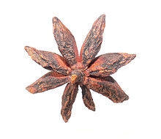

SEARCH 1: “BROWN SMALL STAR SHAPE”

SEARCH 2: “WOODEN STAR SHAPE”

7. How would you find out the name of this famous person using a search engine? What key words/queries would you use?

SEARCH 1: “FAMOUS PRETTY GIRL YOUNG BROWN HAIR”

SEARCH 2: USE IMAGE SEARCH

SEARCH 3: TRENDING ITEMS



8. Your friend and you can’t agree on how *Thandie Newton* pronounces her first name. How would you resolve this using a search engine?

SEARCH 1: YOUTUBE THANDIE NEWTON AND PRAY FOR AN INTERVIEW WHERE SHE SAYS HER NAME.

SEARCH 2: WIKIPEDIA HER NAME AND LOOK FOR PHONETIC SPELLINGS INDICATING HOW TO PRONOUNCE IT.

SEARCH 3: RETURN TO YOUTUBE AND LOOK FOR INTERVIEWS.

9. How would you identify what breed this animal is using a search engine? What key words/queries would you use?

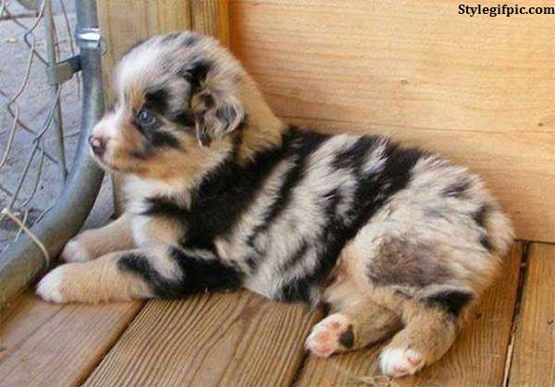

10. What would you search for to identify this pattern’s *name*, and which *country* it originates from?

11. How would you search for delay’s relating to your (imminent) flight to Paris?

**Part 2.**

<http://aspergerstest.net/aq-test/>

Go to the link above and report back your score on the Autism Quotient. There are 2 formats, please take ‘AQ Quiz Option 1’.

Your score here: 11